Hadestown Fan Page Site Plan

Carson John

WDD 130

Overview

Purpose
My purpose is to introduce those who have not listened to Hadestown to the hit musical Hadestown, and teach them how amazing the music and story is.

Audience
My audience is people who have not listened to Hadestown the Musical.

Branding

Website Logo
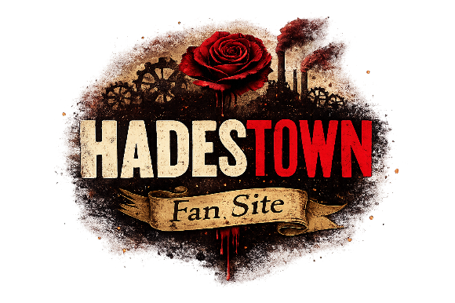

Style Guide

Color Palette
Primary | Secondary | Accent 1 | Accent 2
##000000 | #800020 | #b5a642 | #aaaaaa

Typography

Heading Font: Pirata One

Paragraph Font: Old Standard TT

Navigation
Home Characters

Home

Welcome to the Underworld
Hadestown is a Tony Award–winning musical that retells the ancient Greek myth of Orpheus and Eurydice through powerful music, storytelling, and stunning stage design.

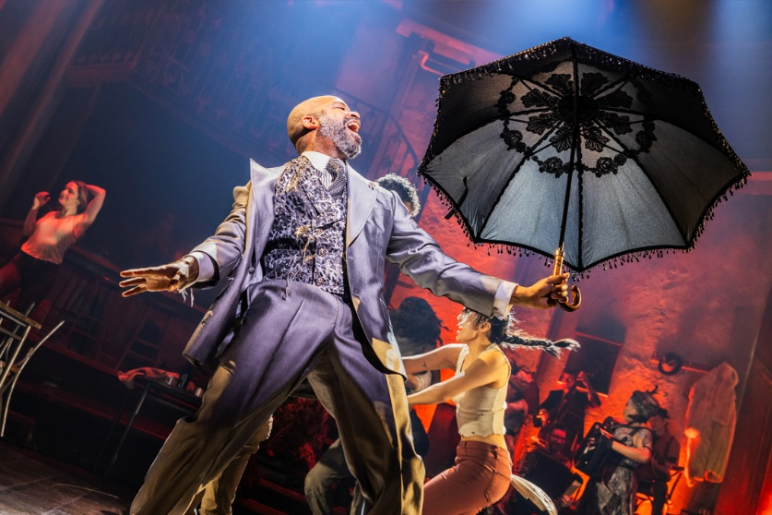

About the Musical
Hadestown follows Orpheus, a dreamer and musician, and Eurydice, a young woman struggling to survive in a harsh world. When Eurydice is tempted by the safety of the industrial underground city ruled by Hades, Orpheus must journey into the underworld to rescue her.

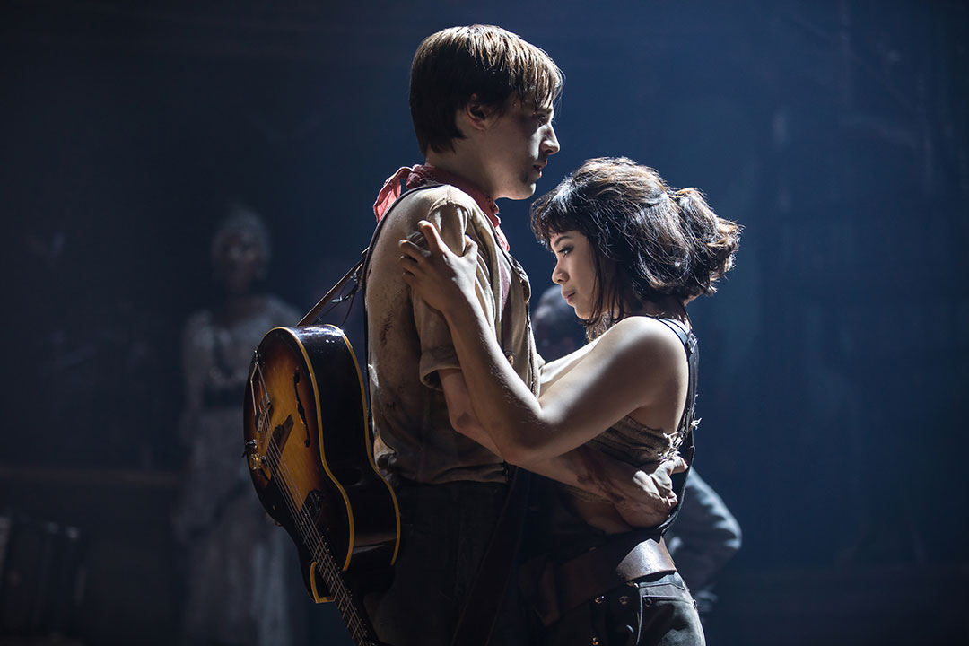
The musical blends folk, jazz, blues, and New Orleans–inspired music to tell a timeless story about love, hope, and the power of music.

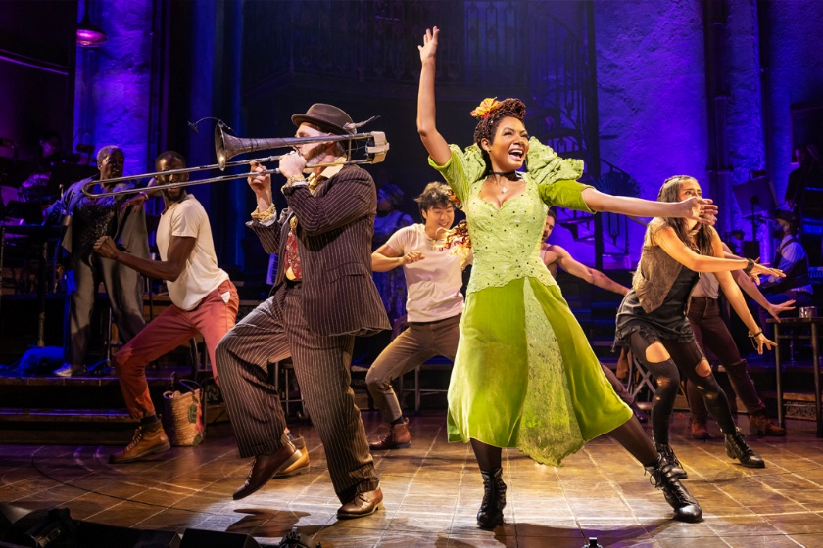

Characters

Orpheus
Orpheus is a hopeful musician who believes his songs can change the
world. His love for Eurydice drives him to travel into the underworld to rescue her from Hades.

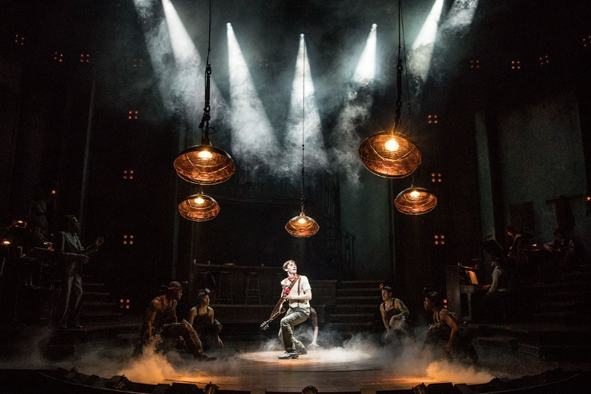

Eurydice
Eurydice is practical and independent. She struggles to survive
in a difficult world and is tempted by the promise of safety
offered by Hades in the underground city of Hadestown.


Hades
Hades rules the industrial underworld known as Hadestown.
He is powerful and controlling but also deeply lonely,
especially in his strained relationship with Persephone.

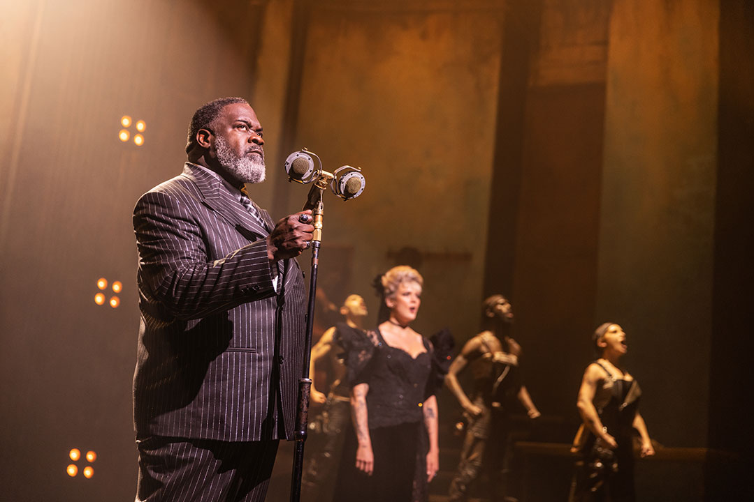

Persephone
Persephone is the queen of the underworld and goddess of spring.
She moves between the world above and Hadestown, bringing warmth, life, and rebellion against Hades' strict control.

Hermes
Hermes acts as the narrator of the story, guiding the audience
through the tale and helping Orpheus on his journey to the
underworld.

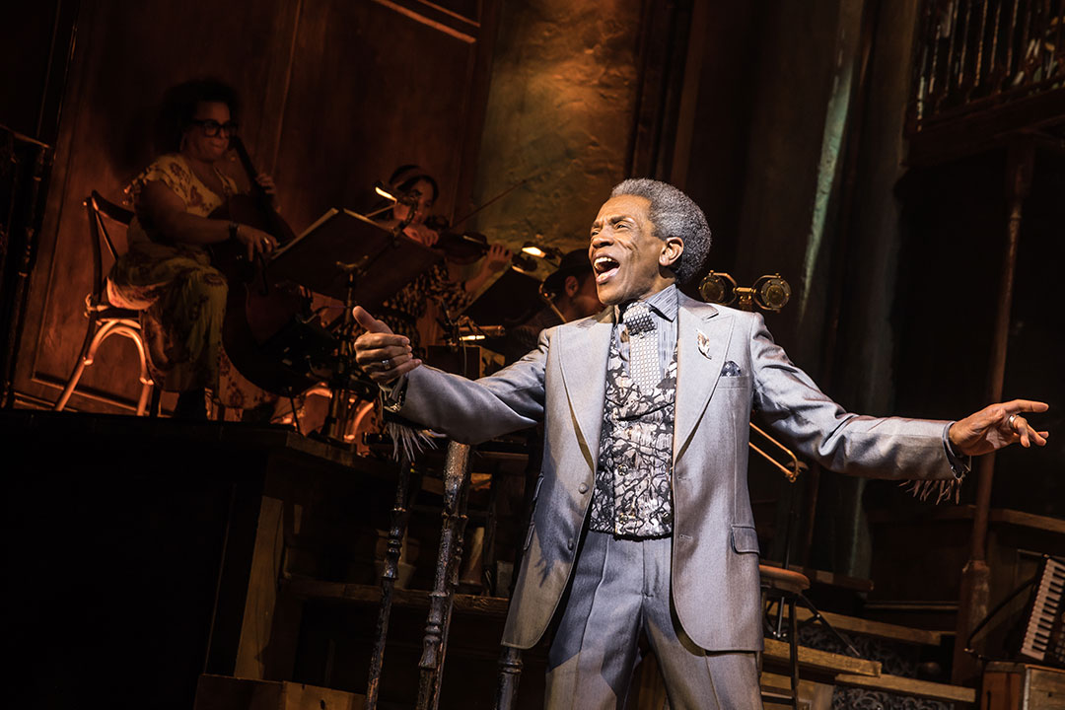

Wireframes

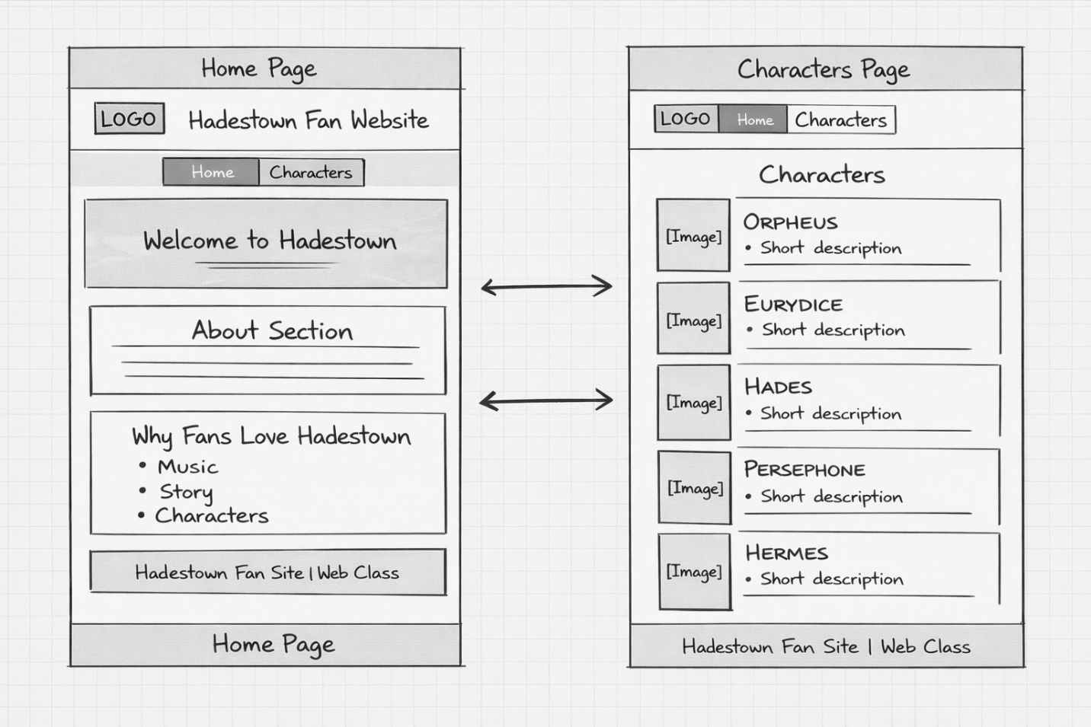

If the wireframes look like butt, it’s because AI designed them, and everything AI designs looks like butt. But here you go.

